Understanding Authentication
Authentication is the process or action of verifying the identify of a user or process.
Eg:- If you delete any pod in a cluster by using kubectl delete command first it will ask “who are you? Authenticate first”. With the authentication it will delete the pod. Same like our windows login asking for you login creds.
Let’s try to authenticate the cluster as anonymous user.
For that go to .kube in local system and open ‘config’ file. From there collect the ‘server’ url in ‘cluster’
“server: https://01d364ab-c23b-49a1-b7ed-f6be179c630b.k8s.ondigitalocean.com”
Now if you do curl it will show you as anonymous.
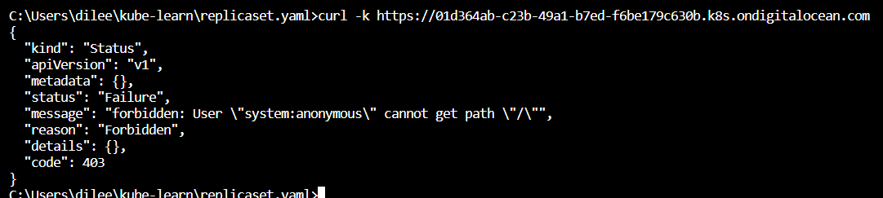
Important Aspect:-
K8s does not have objects which represent normal user accounts.
K8s does not manage the user accounts natively.
Authentication Strategies:-
There are multiple ways in which we can authenticate. Some of these include:
- Usernames/Passwords.
- Client Certifiactes.
- Bearer tokens
- Etc
For more info related to authentication go here Authenticating | Kubernetes .
Now we are going to see “bearer token”. For that we will collect the ‘token’ in ‘config’ file in .kube folder and then we will ‘curl’ it with ‘header’.
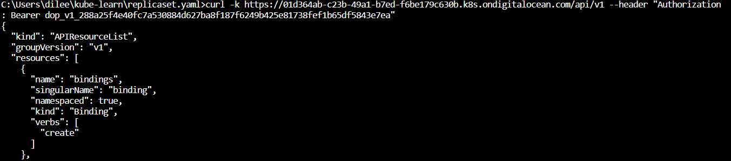
Now you can see with the help of token you can access the cluster.

Authenticating with K8s using Tokens

Let’s create service account with the name of ‘external’ and manifest for a pod.
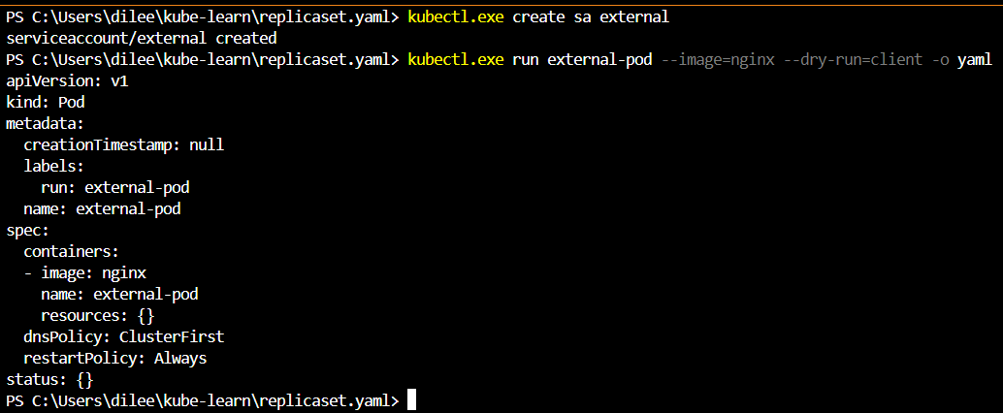
Now create a file with the name ‘sa-pod.yaml’ and paste the manifest to it and add ‘serviceAccount’ to it.
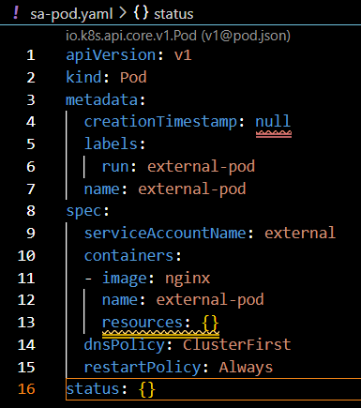
Now jump into the pod and collect the token from ‘token’ file by jumping into /run/secrets/Kubernetes.io/serviceaccount/
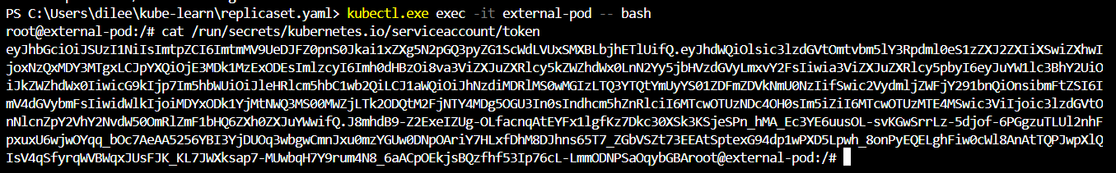
After collecting it, now go to config file inside our local machines .kube folder and collect the ‘server’ link in ‘cluster’ and collect the token as well from pod and do the ‘curl’ like below.
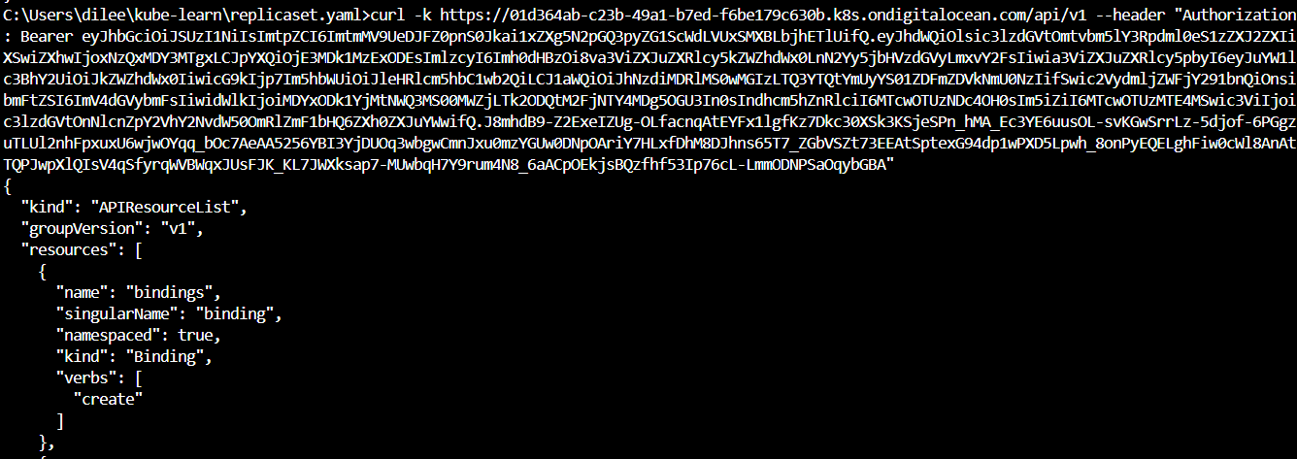
You can see from above that curl -k <cluster’s server url> --header “Authorization: Bearer <pod token>” Can access the cluster.
Overview of Authorization
Basics of Authorization:-
Authorization is the process of giving someone permission to perform some operation.
Authorization Modules:-
K8s provides multiple authorization modules like:
- AlwaysAllow
- AlwaysDeny
- Attribute-Based Access Control (ABAC)
- Rol-based access control (RBAC)
- Node
- WebHook
RBAC:-
It’s very important one which we use in our PROD env.
Two Concepts:-
- A role contains rule that represent a set of permissions.
- A role binding grants the permissions defines in a role to a user or set of users.
Role Binding:
ReadSome
- Dileep
- Pawan
Role ReadSome
Allow:
Read pods
Read services
Read Secrets

The script related to role and role binding you can find in K8s doc Using RBAC Authorization | Kubernetes .
Now we do ‘curl’ for ‘pods’ which are having ‘default’ ‘namespace’ it will show forbidden error because the user is not authorized to access it.
If you see the highlighted one below we have added the extra path after ‘api/v1’
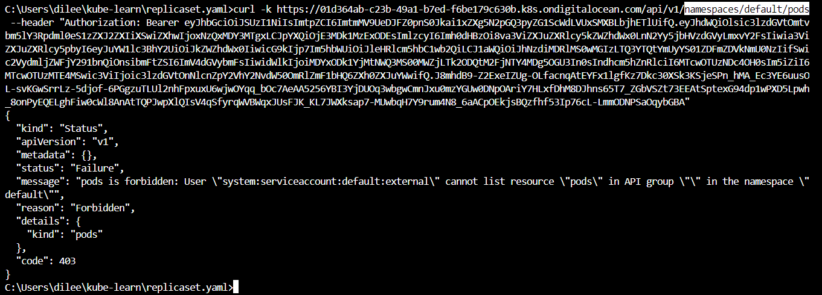
Now by using RBAC we are going to get default nameSpace’s pods.
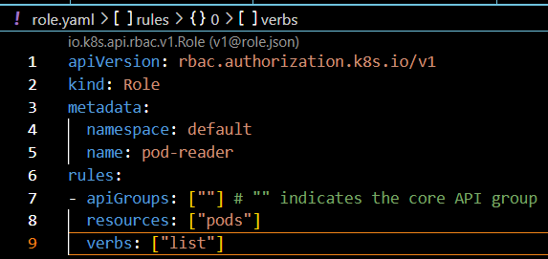
From above script we are going to create a ‘role’ with the name of ‘pod-reader’ and we are going to list the pods which you can see it in ‘verbs’ and ‘resources’ session.
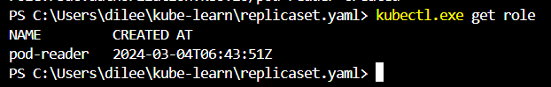
You can see ‘pod-reader’ role has been created..
If you run describe it will display the ‘verb’ and ‘resource’.
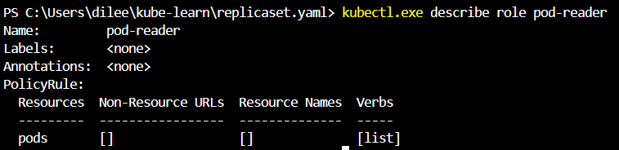
Rolebinding:-
Now got K8s doc get the example of rolebinding and create a file with the name of ‘rolebinding.yaml’ paste and save it.
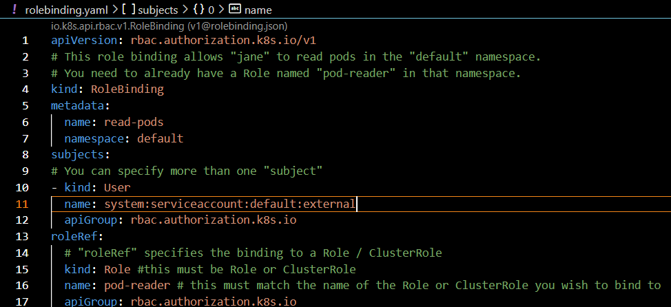
The tutor had removed the comments but I kept it for my reference.
The user ‘Jane’ which the comments are refering to has been changed to ‘system.serviceaccount:default:external’ .
After ‘apply’ command you can list the rolebinding and collect the name of the rolebinding to ‘describe’ it. There you can see the ‘user’ and the ‘role’ which are attached to the rolebinding.
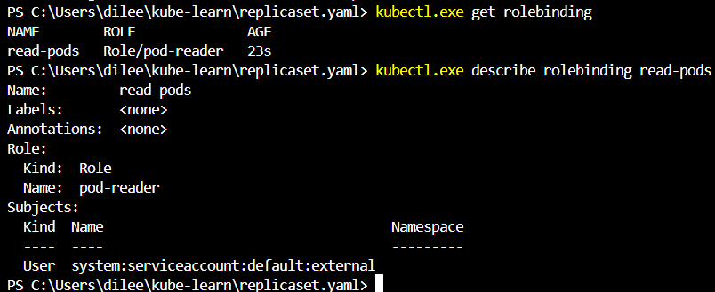
The user name we got it from previous error for curl command where it was showing ‘user …… can’t list the resource’ .
Now if you run “curl -k <cluster link/api/v1/namespaces/default/pods > --header “Authorization: Bearer <token>”. It will list the all pods which are under default namespace.
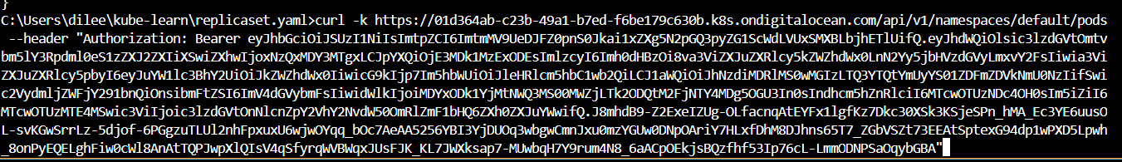
ClusterRole and ClusterRole bindings
Overview of ClusterRole:-
A role can be used to grant access to resources within a single namespace.
A ClusterRole can be used to grant the same permissions as a Role, but because they are cluster-scoped, they can also be used to grant access to:
- Cluster-scoped resources (like nodes)
- Namespaced resources (like pods) across all namespaces.
To create it again we need to got K8s doc and look for clusterRole example and collect the script.
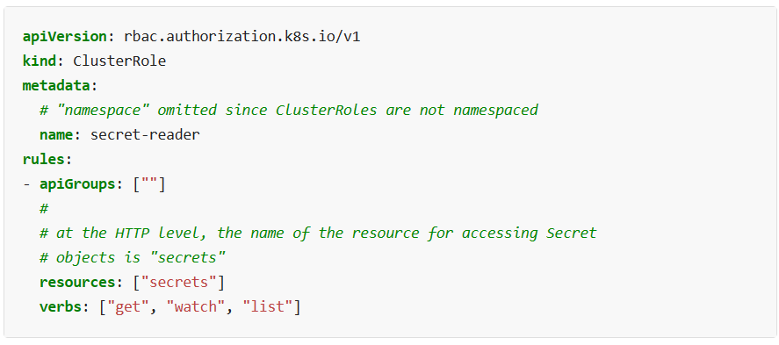
In the earlier ‘role’ we have ‘namespace’ to define but for ‘clusterRole’ there is no ‘namespace because it’s global and even you can’t see it in ‘clusterRole binding’.
If you want to delete a resources which was created with the script Just run ‘kubectl delete -f <XXX.yaml>
Now let’s create cluster role:-
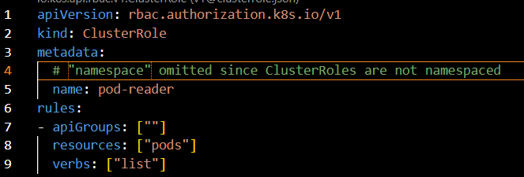
If run ‘desribe’ command.
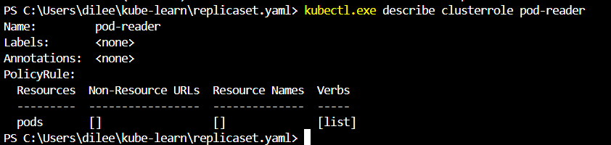
Let’s create ClusterRoleBinding:-
Collect the script from K8s doc and create a file with the name of ‘cluster-role-binding.yaml’ paste aand save it.
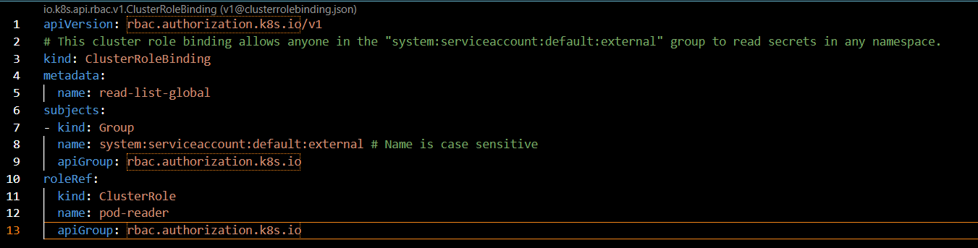
Now run the describe command
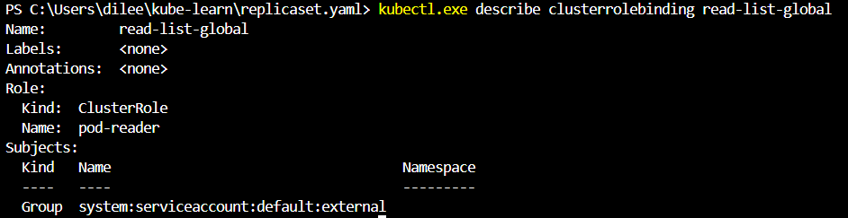
You can see the pod-reader clusterRole has been attached to the ClusterRoleBinding.
However if we create a new ‘namespace’ with the name ‘external’. If we do curl with url extensions of ‘/api/v1/namespaces/external/pods’ it will list the pods from the ‘external’ namespace. Because we have created the role in cluster level and it’s global level for namespace.
Important Pointer:-
A RoleBinding may also reference a ClusterRole to grant the permission to resources defined in the ClusterRole within the RoleBinding’s namespace.
This allows administrator to have set of central policy which can be attached via RoleBinding so it is applicable at a per-namespace level.
Need to check:- The ClusterRole can be attached to Rolebind like below image
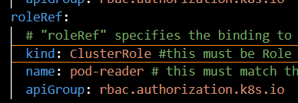
Need to check importance of it.
Introduction to Asymmetric Key Encryption
Overview:- Asymmetric cryptography, uses public and private keys to encrypt and decrypt data.
One key in the pair can be shared with everyone; it is called the public key. The other key in the pair is kept secret; it is called the private key.
Either of the keys can be used to encrypt a message; the opposite key from the one used to encrypt the message is used for decryption.
Eg:-
Alice has public key and private key. Alic will share the public key among the users to communicate with Alice.
Bob got the Alice’s public key he sends “Hello Alice” the public key which he got will encrypt the message and it will go to Alice. The Alice’s private key will decrypt it and the text which Bob sent that Alice can read it.
Sender -> Public key—Encrypt Private key -> Receiver
Protocols:-
Asymmetric key encryption is used by variety of protocols.Some of these includes:
- PGP
- SSH
- Bitcoin
- TLS
- S/MIME
Understanding SSL/TLS
Overview of HTTPS:-
HTTPS is an extension of HTTP.
In HTTPS, the communication is encryption using Transport Layer Security (TLS).TLS is newer version of SSL.
The protocol is therefore also often referred to as HTTP over TLS or HTTP over SSL.
Scenario 1: MITM Attacks
- User is sending their username and password in plaintext to Web Server for authentication over a network.
- There is an Attacker sitting between them doing a MITM attack and storing all the credentials he finds over the network to a file
Scenario2: MITM & Intergirty Attacks
- Attacekr changing the payment details while packets are in transit.
Introduction to SSL/TLS:-
To avoid the previous two scenarios (and many more), various cryptographic standards were clubbed together to establish a secure communication over and untrusted network and they are known as SSL/TLS.
Protocol | Year
SSL 2.0 | 1995
SSL 3.0 | 1996
TLS 1.0 | 1999
TLS 1.1 | 2006
TLS 1.2 | 2008
TLS 1.3 | 2018

Understanding it in easy way:-
Every website has a certificate (like a passport which is issued by a trusted entity).
Certificate has lot of details like domain name it is valid for, the public key, validity and others.
Browser (clients) verifies if it trusts the certificate issuer. I t will verify all the details of the certifctae. It will take the public key and initiate a negotiation.
Asymmetric key encryption is used to generate a new temporary symmetric key which will be used for secure communication.
*** Need to check how to decrypt the token.
Deep info about SSL/TLS. Rewatch of you need understand more about it.
Creating TLS certificate for Authentication
Our goal is to setup an authentication based on X509 Client certificates.
User A should be able to authenticate with K8s Cluster with his certificates.
Process:-
dileep-key (openssl) -> dileep.csr (openssl) -> dileep.csr(K8s object) -> K8s CA -> dileep.crt
Step1:- We will use openssl command to generate a key.
Step2:- Once the above key is created we ill create create certificate sigining request (csr) by using that key.
Step3:- With the csr we will create K8s object and this K8s will having contents of the csr.
Step4:- The K8s Object when uploaded to K8s server you can either approve it or deny it. If you approve it, it will create a certificate.
Once you have certificate you can make use of the key that was generated part of first step and certificate . we can use both of them along with client (kubectl/curl) to authenticate kube api server.
Hands on:-
To do above steps we need to either config few things like env variables and other things in our windows or mac book. Regarding this I’m going to use Linux server in Digitaal ocean.Create a droplet with password.
Follow the below steps which was given by instructor certified-kubernetes-administrator/Domain 4 - Security/certificate-steps.md at master · zealvora/certified-kubernetes-administrator · GitHub .
One of the prerequisite is the server which wants to connect K8s ccluster must be having kubectl and kube config.
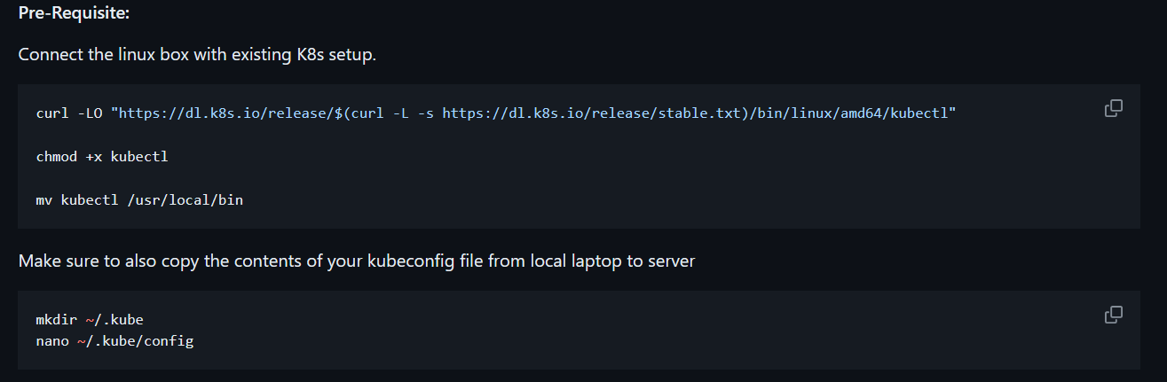
First we are going to create kubectl for that we are going to run above mentioned step1 steps.
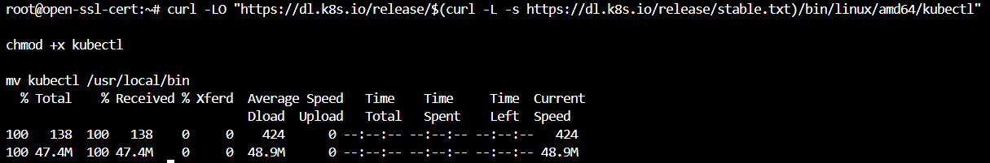
Now you can run the kubectl command successfully.
Now we need to config kube config.
For that we need to create a .kube folder and then need to create ‘config’ file.Now we need to copy the config file content which was already in our local system to the ‘config’ file on linux.
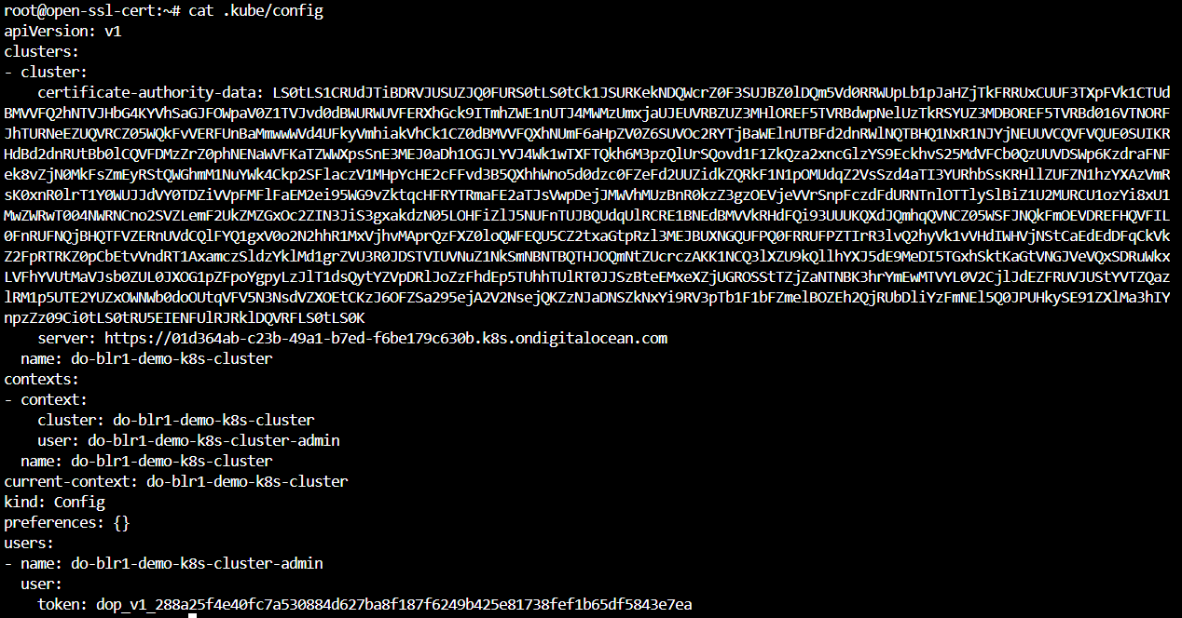
Now if your kubectl get pods it will show the output.
Now step2:-
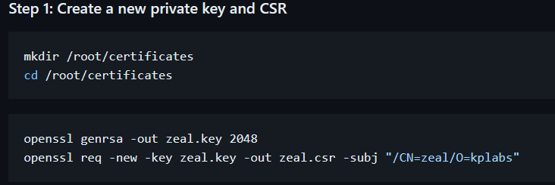
Run above mentioned commands here instead of zeal.key I have created dileep.key.
openssl genrsa -out zeal.key 2048
The above command will create the zeal.key
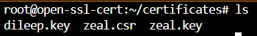
openssl req -new -key zeal.key -out zeal.csr -subj "/CN=zeal/O=kplabs"
It will generate the csr file.
For the certificate signing request it won’t take the csr as it is whatever we generated we need to encode it.
Before encode:-
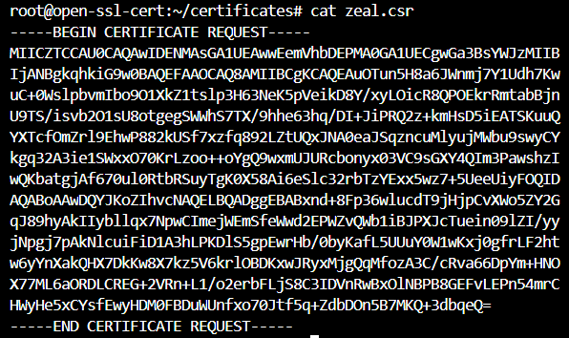
After running below command it will encode it
cat zeal.csr | base64 | tr -d '\n'
After encode:-
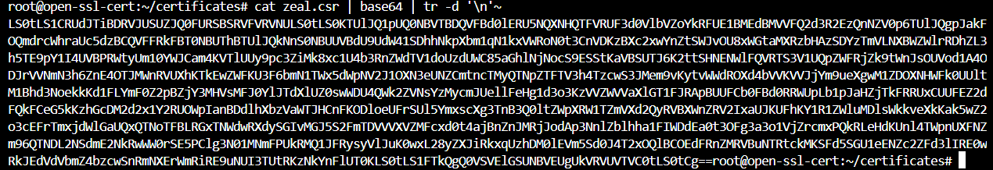
From above SS copy till before root@open.....
Now create yaml file.
Collect the script from above mentioned repo and paste it in the yaml file and the encoded key you need paste it in request you can see below image.
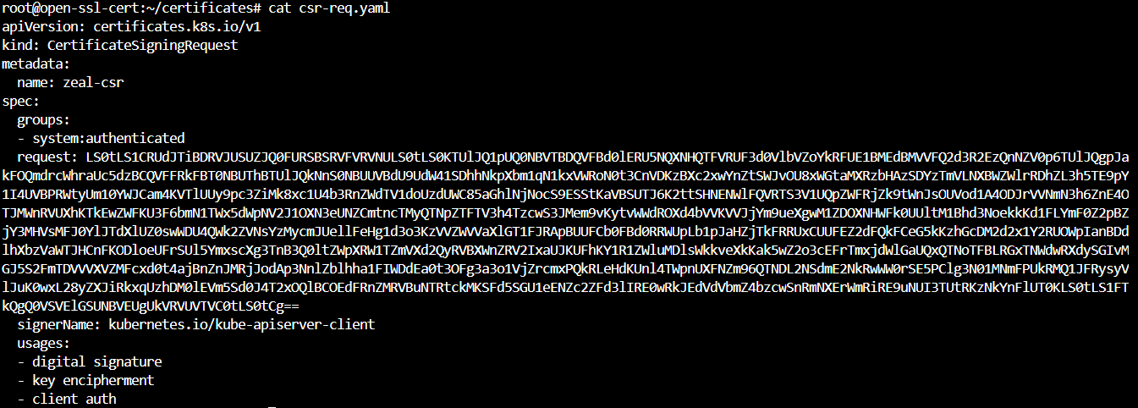
To verify run ‘kubectl get csr’
Now if you see above SS ‘CONDITION’ is showing ‘Pending’.
Now we need to approve the csr. To approve
kubectl certificate approve zeal-csr
Now you can see the output.
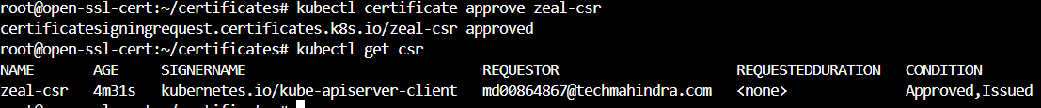
Now we need to authenticate the Kube-api server through ssl key or certificate.
Now we need to download the certificate from K8s to the workstation.
Run
kubectl get csr zeal-csr -o jsonpath='{.status.certificate}' | base64 -d > zeal.crt
if we do ls you see zeal.crt
Now we are config the context.
If you see the ‘config’ file in .kube there you can see the user ‘do-blr1-demo-k8s-cluster-admin’. Now we are going to create another user to authenticate it that ‘zeal’ .
If you do ‘cat config’ you can see the user zeal
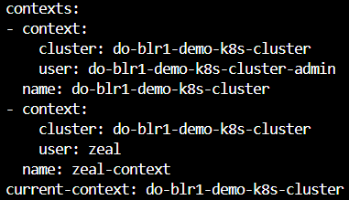
Now we have user but we don’t have token or certification to Authenticate it. For setting the credentials for user ‘zeal’
For that Run.
kubectl config set-credentials zeal --client-certificate=zeal.crt --client-key=zeal.key

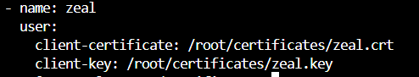
Now if you run ‘kubectl config get-contexts’ you can see the one more context of ‘zeal-context’.
If you run get pods command it will run from the ‘do-blr1-demo-k8s-cluster’ not from ‘zeal-context’.
Now we need to change that, for that.
kubectl --context=zeal-context get pods

It will show the forbidden error for that we need to create RBAC.
For me I got this
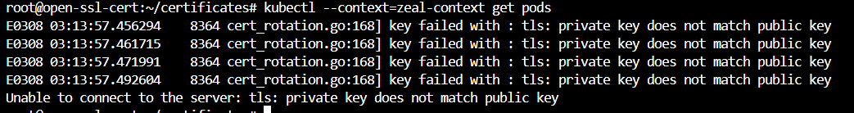
Need to check
Create a role.yaml
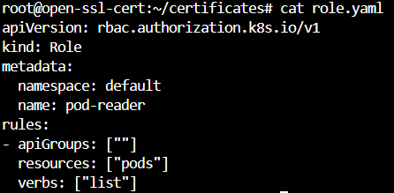
Now create role-binding.yaml
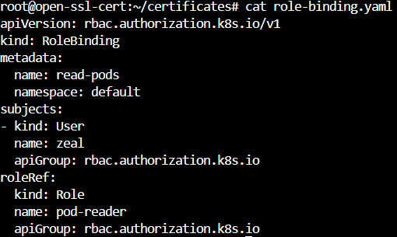
In above script you can see the subjects there we have mentioned the ‘name’ as ‘zeal’.
If you run the list command you will be able to see the pods list.
kubectl --context=zeal-context get pods
Still getting the same error need to check.
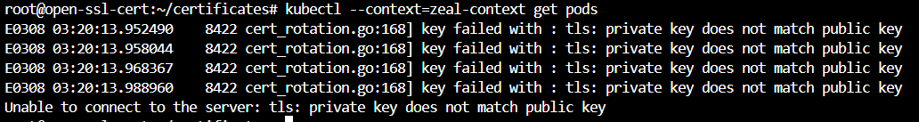
Understanding Kubeconfig
Kubectl command uses kubeconfig files to find the info about the cluster, username, authentication mechanisms and others.
Kubeconfig(Server:abc.com,user:zeal,token:12345) <-> Client(Kubectl/curl) -> kube-api
Access to Multiple clusters:-
Kubeconfig file can also have details associated with multiple K8s clusters.
Kube-api
Kube-api
Client
(kubectl)
Kubeconfig
Server: abc.com
User:zeal
Token:12345
Server:zyx.com
User:zeal
Token:6789

Step1- Understanding Clusters Field
Cluster field has details related to the URL of your K8s Cluster and it’s associated info.
Kubeconfig file is having
- cluster
server: abc.com
name:cluster1
- cluster
server: zyx.com
name:cluster2
Step2- Users Field
User field contains authentication like username, passwords.
There can be different type of authentication mechanisms (user/pass, certificates, tokens etc)
- cluster
server: abc.com
name: cluster1
users:
- name: adminuser
user:
token:12345
Step3- Context Field:-
Context groups info related to cluster, user and namespace.
- cluster
server: abc.com
name: cluster1
- context:
cluster: cluster1
namespace: kplabs
user: adminuser
users:
- name: adminuser
user:
token:12345
Whenever we run kubectl get pods are any command First it will go to ‘current-context’ and fetch the details from there and then it will go to ‘cluster’ in ‘context’ and whatever the specified cluster in context from there it will refer to the ‘server’ details in ‘cluster’ and then it will go and try for the Authentication form ‘users’ session and it will connect to default namespace or kplabs.
Another way to check the kubconfig file is ‘kubectl config view’
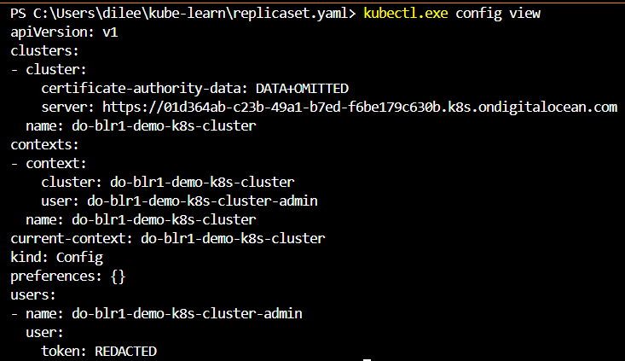
Everytime adding attaching/running a pod with namespace like ‘kubectl pods –namespace kplabsns’
We can hardcode the namespace in config file. Just go and add the ‘namespace: kplabsns’ in ‘context’ .
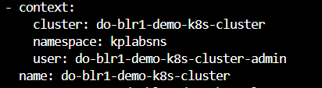
Now if you do ‘kubectl get pods’ it will show the contents which is specific related to ‘kplabsns’ namespace.Since you are not in ‘default’ namespace to list pods under ‘default’ run ‘kubectl get pods –namespace default’ .
Creating kubeconfig from Scratch
Step1:- Add cluster details
Kubectl config - -kubeconfig=base-config set-cluster development - - server=https://1.2.3.4
From above command it will create a file with base-config like our config file and it will create a cluster with the name of development which is having server=https://1.2.3.4
If you do cat for base-config file it will be having all the values which ‘config’ file is having.
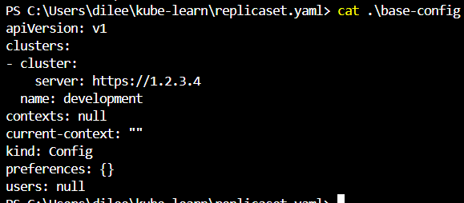
Step2:- Now we need to create user details because we need to authenticate the cluster
For that
kubectl.exe config --kubeconfig=base-config set-credentials experimenter --username=dev --password=some-passwd
If you do cat for base-config you can see the user details.
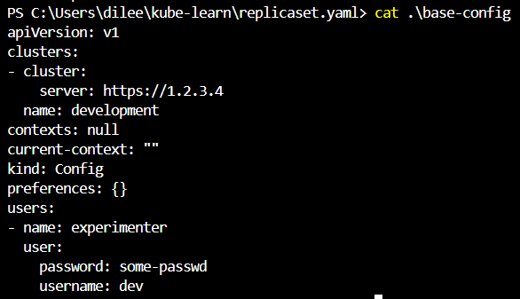
Step3:- Setting contexts
To setup context
kubectl.exe config --kubeconfig=base-config set-context dev-frontend --cluster=development --namespace=frontend --user=experimenter
Now if you see ‘base-config’ you can see the context.
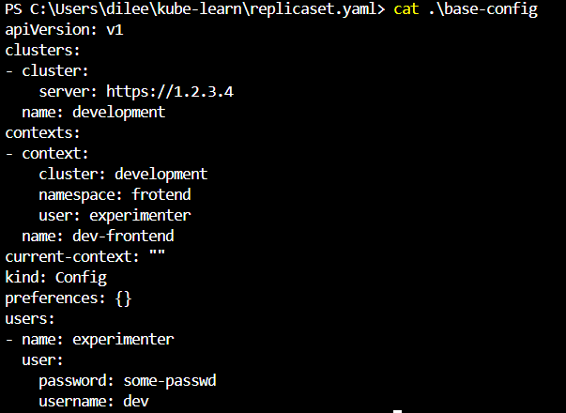
Creation of second cluster:-
We are going to repeat the same commands this time it’s for Production.
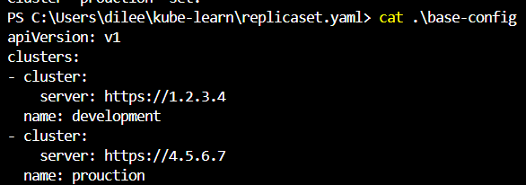
Now add context to it but here we are using the same user
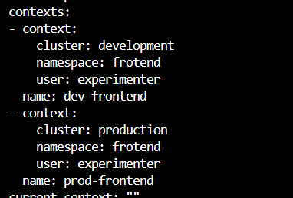
To see the content of ‘base-config’ file
Kubectl config –kubeconfig=base-config view
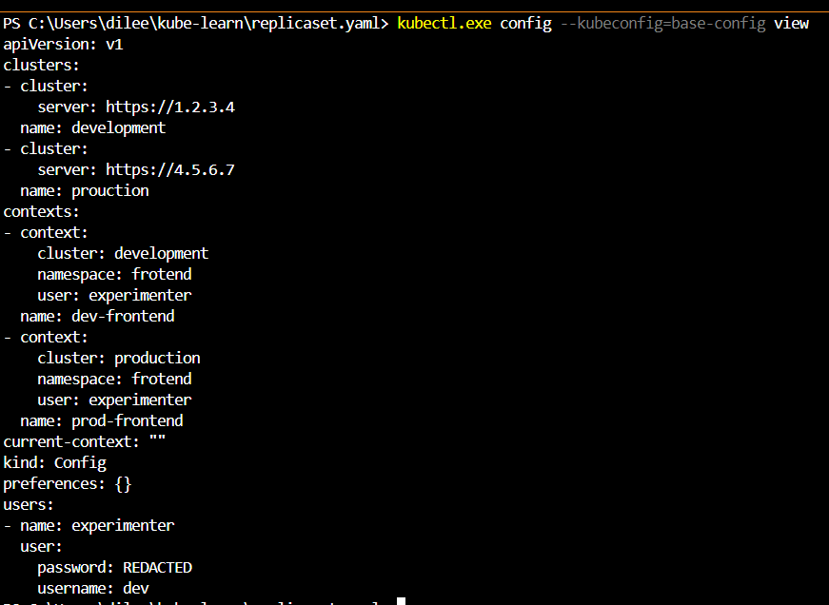
To list the context of ‘base-config’
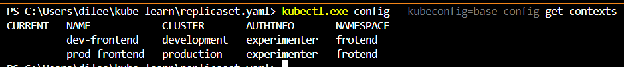
Now, If you see current context is not specified. Let’s assume a Developer wants to use ‘dev-frontend’ context we need to run “kubectl.exe config --kubeconfig=base-config use-context dev-frontend”
You can see the ‘*’ is pointing to ‘dev-frontend’
You can see same in base-config file.
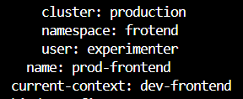
Now if you want to switch to prod context need to run “kubectl.exe config --kubeconfig=base-config use-context prod-frontend”
Kubernetes Secrets
Use-Case:
AppA runs on a pod it needs to connect to MySQL DB to start working properly.
Many a times you will find that developer have hardcoded credentials within their container image.
Common Approach:Risks:-
There are multiple risks of hard coding credentials:
- anyone having access to container repo can easily fetch the credentials.
- Developer needs to have credentials of production systems.
- Update of credentials will lead to new docker image being quit.(during password reset cycle like every 90 days needs to reset)
Storing Credentials Centrally:-
db_user=admin
db_pass_12345
Central Secret Store

Authenticate with user:pass
MySQL
AppA Pod
Advantages of above approach:
- Developer not required to hardcode it.
- Developer will not having the credentials all he needs to do is write the logic to pull the credentials.
- Since it’s stored in central secret store even if password gets changes the apps will not get effect.
Other 3rd party providers for credentials store are:-
- AWS Secrets Manager
- AWS systems manager Parameter store
- HashiCorp vault
Overview of K8s Secrets:-
A secret is an object that contains small amount of sensitive data such as a password, a token, or a key.
- Allows customers to store secrets centrally to reduce risk of exposure.
- Stored in ETCD database
CLI Syntax for Creating Secret:-
Kubectl create secret [TYPE] [NAME] [DATA]
Elaborating TYPE:
- Generic:
- File (--from-file)
- directory
- literal value
- Docker Registry
- TLS
Now we need to create a secret
Generic-literal:
To verify
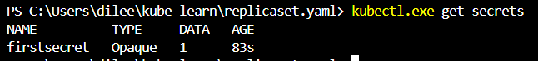
Kubect describe secret firstsecret
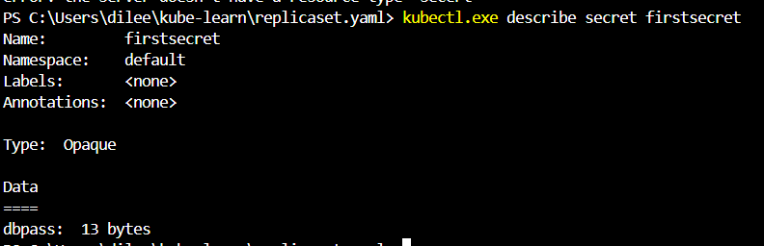
To read the secret “kubectl get secret firstsceret -o yaml”
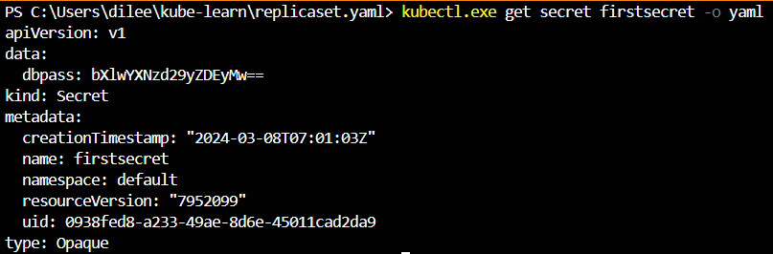
You can see “dbpass: bXlwYXNzd29yZDEyMw==” as the password but that is not the exact password which we configured. In linux machine run “echo bXlwYXNzd29yZDEyMw== | base64 -d” it will show the password. If it’s windows search in google.
Generic-file:
Create a file with the name of credentials.txt and add the value
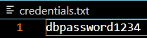
After saving it run “kubectl.exe create secret generic secondsecret --from-file=./credentials.txt”
If you list it
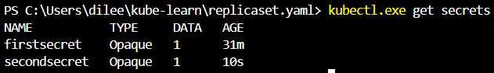

Through Yaml.
apiVersion: v1
kind: Secret
metadata:
name: thirdsecret
type: Opaque
data:
username: abadmin
password: Secret123
If we give like above it won’t take because password is in plain text. We need to encrypt it and then configure it by using “echo -n ‘dbadmin’ | base64” and “echo -n ‘Secret123’ | base64”
But to avoid this we need to use “stringData”.
apiVersion: v1
kind: Secret
metadata:
name: strindata
type: Opaque
stringData:
config.yaml: |-
username: dbadmin
password: Secret123
With the help of stringData we can directly give secrets as plain text.
Mounting Secrets Inside Pods
Mounting secrets in Containers:-
Once a secret is created, it is necessary to make it available to containers in a pod. There are two approaches to achieve this:
- Volumes
- Environment variables
Volumes:-
For that we need to write a YAML script but before that if you see the firstsecret “kubectl.exe get secret firstsecret -o yaml” It will be having “dbpass: bXlwYXNzd29yZDEyMw=”
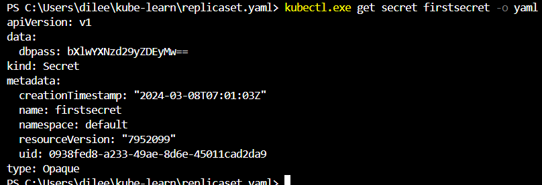
We need to call that variable ‘dbpass’ with it’s name ‘firstsecret’
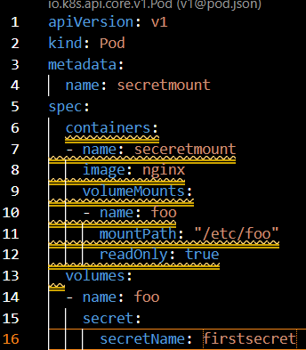
You can see dbpass inside the pod inside /etc/foo
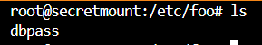
If you do cat you can see the password
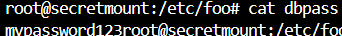
Ignore root@.....
Environment Variables:-
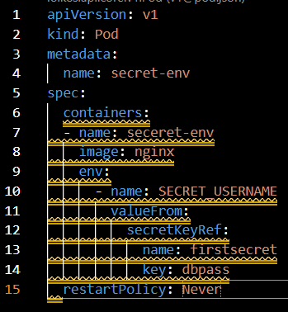
From above script “SECRET_USERNAME” is a variable and placeholder you can see it’s dbpass from ‘firstsecret’.
To verify this login to pod and run “echo $SECRET_USERNAME”.
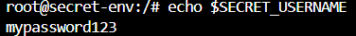
The above 2 methods will decode the keys and we don’t need bother about it.

